Territorial Acquisition Report

The game premise was to create a territorial board game for around 2-4 players. The game worked by having the first person who claimed all territory win or the player with the most territory after ‘X’ amount of time win.

The rules were each player assigned themselves a colour, then placed 2 tiles of that same colour anywhere on the outside of the board, after this all other tiles must be placed next to a tile of the same colour.

The game is played within 10 turns overall and within each turn the players can place two more tiles on the board. Players can take tiles from others if they are next to tiles of their own colour.

Each hexagon is worth more as it gets towards the centre, so outer hexagons are worth less than the hexagons that are in the centre of the board.

The aim of the game is to get as many points as possible before the end of the game.

To make the game a board would be required and, also either some counters or different coloured pens to mark on the different colours of the players.

The design of the board is shown in the screenshot below:

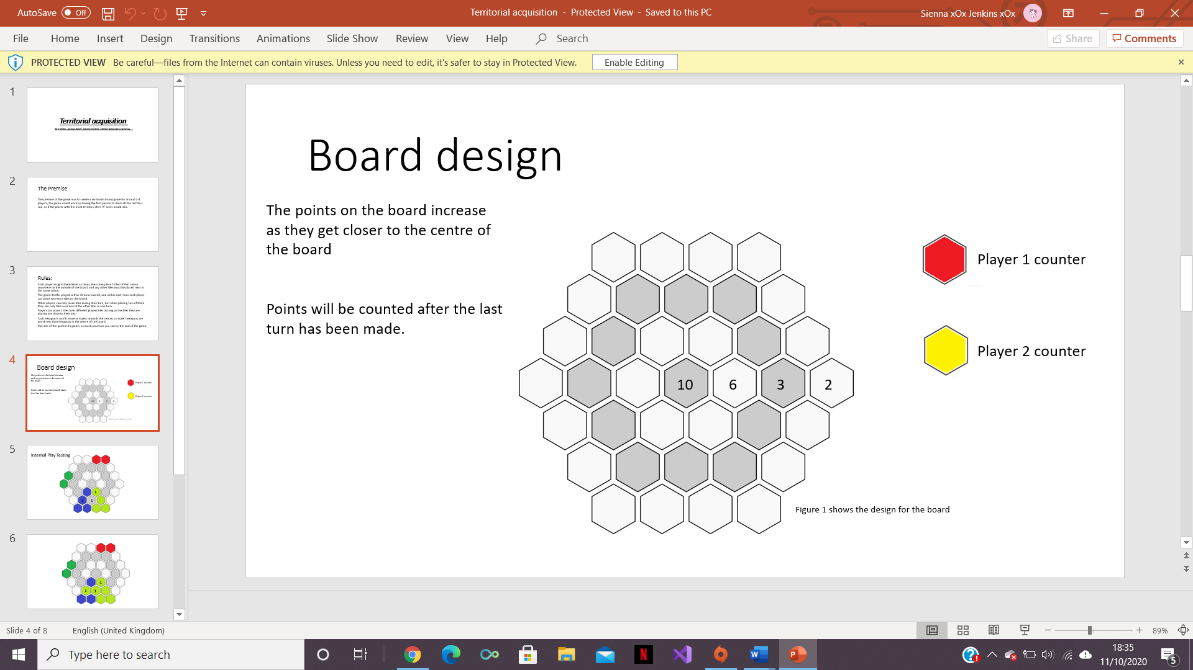

In the screenshots below internal play testing and game development in shown:

The game was played by each player placing their coloured blocks until the whole board was filled and no more blocks could be placed.

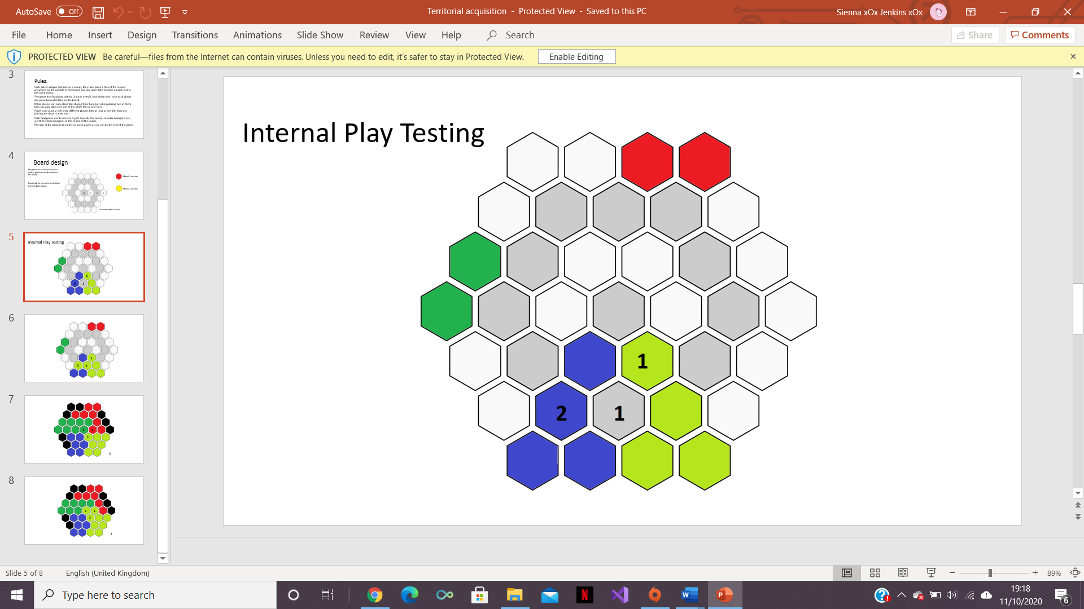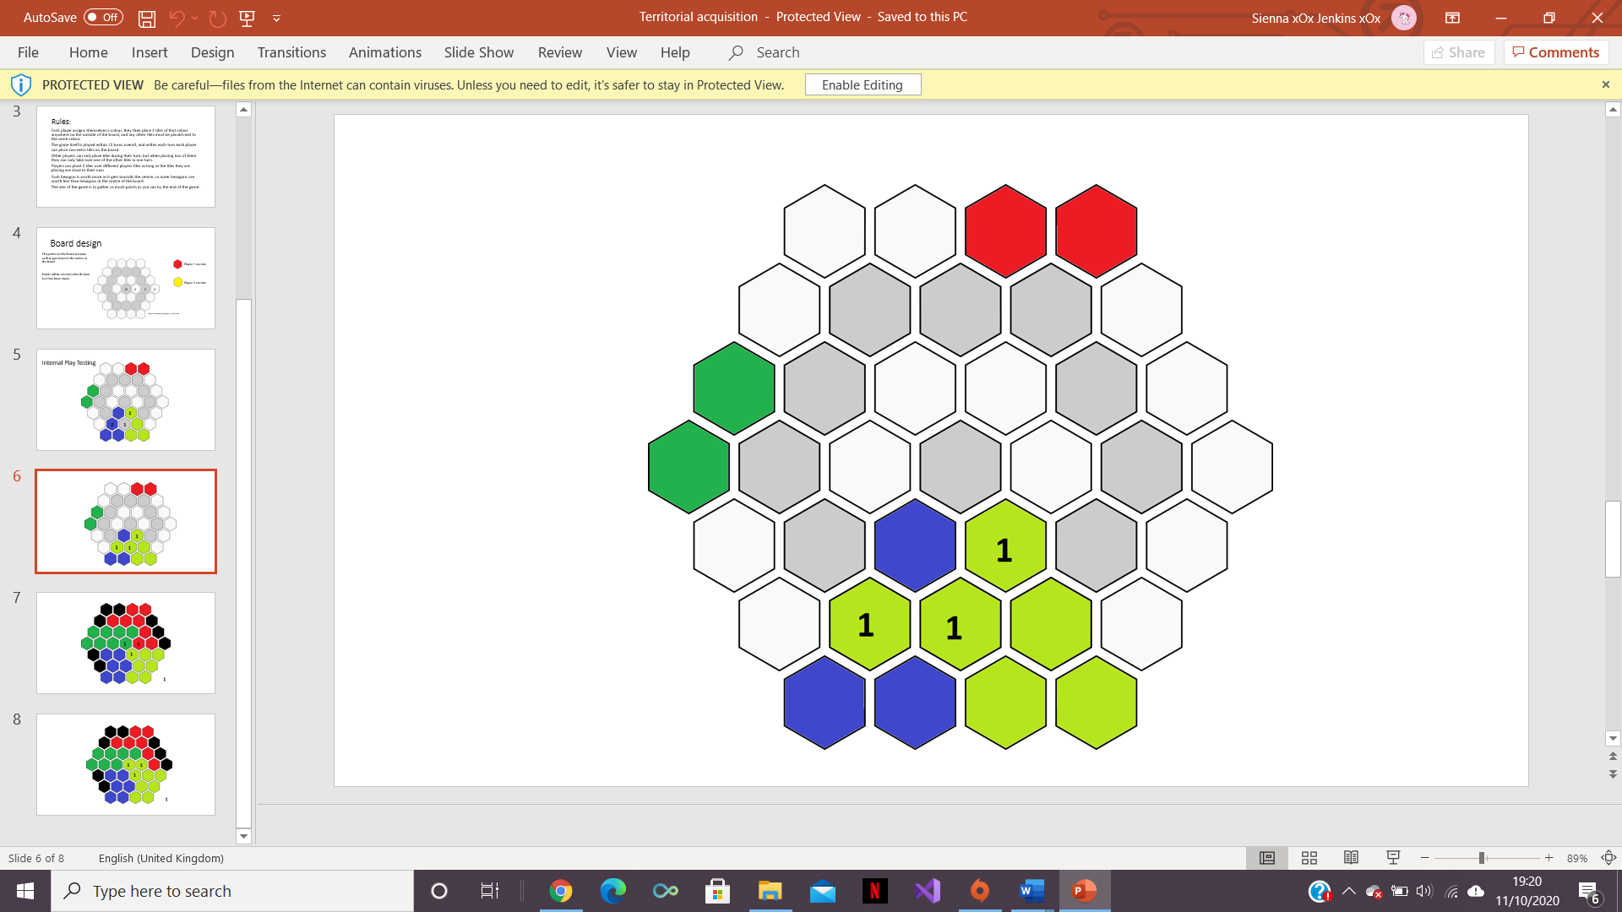

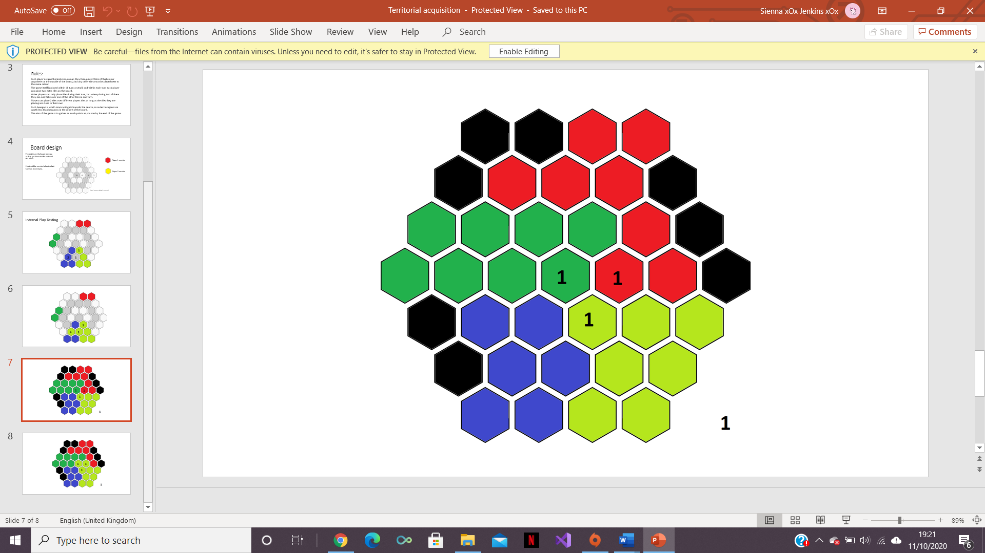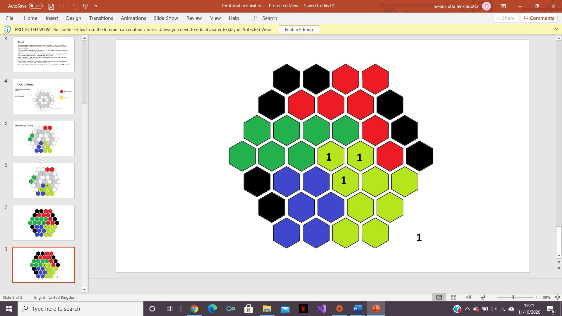

Working in a team made the completion of this task much quicker and smoother and, also allowed for internal play testing. If it had not been a group project, it would’ve been a much harder task and there could’ve possibly been more flaws in the game mechanics.

The team worked well as a group, but it would’ve been useful if external play testing had been completed to get an outsider’s point of view in the functionality of the game.

Members of game design:

Ben Miller,

Joshua Baker,

Sienna Jenkins

And Stefan-Alexandru Zarnescu